OOP 3rd Assignment
BY
MD.Junayed Bin Karim
I’D:0242220005101667
1.
public class ArraySum {
public static void main(String[] args) {
Scanner scanner = new Scanner(System.in);

System.out.print("Enter the number of elements in the array: ");
int n = scanner.nextInt();

int[] arr = new int[n];

System.out.println("Enter the elements of the array:");
for (int i = 0; i < n; i++) {
System.out.print("Element " + (i + 1) + ": ");
arr[i] = scanner.nextInt();
}

int sum = 0;
for (int i = 0; i < n; i++) {
sum += arr[i];
}

System.out.println("Sum of the elements in the array: " + sum);

scanner.close();
}
}
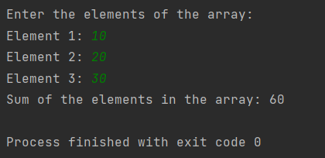

2.
import java.util.Scanner;

public class MaxMinArray {
public static void main(String[] args) {
Scanner scanner = new Scanner(System.in);

System.out.print("Enter the number of elements in the array: ");
int n = scanner.nextInt();

int[] arr = new int[n];

System.out.println("Enter the elements of the array:");
for (int i = 0; i < n; i++) {
System.out.print("Element " + (i + 1) + ": ");
arr[i] = scanner.nextInt();
}

int max = arr[0];
int min = arr[0];

for (int i = 1; i < n; i++) {
if (arr[i] > max) {
max = arr[i];
}
if (arr[i] < min) {
min = arr[i];
}
}

System.out.println("Maximum value in the array: " + max);
System.out.println("Minimum value in the array: " + min);

scanner.close();
}
}
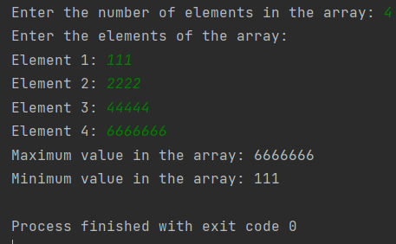

3
import java.util.Scanner;

public class EvenNumbersFromArray {
public static void main(String[] args) {
Scanner scanner = new Scanner(System.in);

System.out.print("Enter the number of elements in the array (N): ");
int N = scanner.nextInt();

int[] arr = new int[N];

System.out.println("Enter " + N + " integers for the array:");
for (int i = 0; i < N; i++) {
System.out.print("Element " + (i + 1) + ": ");
arr[i] = scanner.nextInt();
}

System.out.println("Elements in the array:");
for (int i = 0; i < N; i++) {
System.out.print(arr[i] + " ");
}
System.out.println(); // Print a newline

System.out.println("Even numbers in the array:");
for (int i = 0; i < N; i++) {
if (arr[i] % 2 == 0) {
System.out.print(arr[i] + " ");
}
}

scanner.close();
}
}

